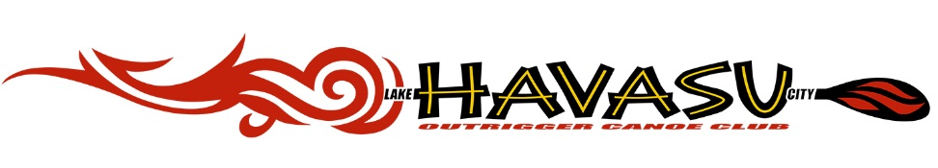
RULES AND POLICIES / CODE OF ETHICS

GENERAL:
- Must obey the instructions, warnings and decisions of the Coaching Staff at all times.
- Do not use canoes, paddles or other club-owned assets without permission from an officer(s).
- Must take responsibility for LHCOCC equipment and area used (ex. Ensuring that all the equipment is put away properly, canoes have been wiped down and removal of any trash items in area).
- Show respect to ALL members and set good examples for future members.
- A member will not be allowed to participate in any paddling activities on or off the water if you are in possession or under the influence of any illegal drugs or alcohol.
- The following behavior by a member may be cause for revocation of membership.
  - Providing coaching or other paddling-related instructions to another member or paddler without specifically being requested to do so by a member of the coaching staff.
  - Incidence of blatant or covert non-compliance with instructions and requests issued by a member of the coaching staff or steersperson.
  - Making disparaging comments about club officers, members of the coaching staff, other club members, crew selections or other issues related to the paddling program.
  - Ignoring instructions of a board member, executive officer, coach or steersperson that would otherwise subject the member or other members to danger, injury, or death, or damage to, or destruction of club equipment.
- If any of the above mentioned behaviors in Section 6 are displayed, the paddler shall be disallowed membership for 3 months. To activate membership after the 3 month period, the member will have to appear before the Board of Director’s. At that time, it will be up to the discretion of the Board of Director’s whether to reinstate or terminate that person’s membership.
- If a paddler disagrees with the coach(es) and/or steersperson, that paddler will speak to an officer concerning the disagreement in a respectful manner.
- This Club is considered a Co-Op sport. We paddle as one, clean and maintain our equipment as one and treat all with the same respect.
- Members are required to participate in the Clubs monthly cleaning day.
- Members are requested to attend the January General Kick Off Meeting. This meeting is the renewal of their Membership / Liability / Code of Ethics for all Members. Forms must be completed yearly.
This meeting is also a formal update and training session.
- Members are requested to attend at least (3) General Meetings yearly.

LAUNCHING AND CARING FOR CANOES:
- Never run in the canoe area or roughhouse while waiting to enter the canoe.
- Never step over the top of the canoe; always enter from the ama side (left side) of the boat.
- Clothing, shoes and other articles should be stored in the waiting area and not in the canoe hull.
- Listen to the coaches and steersperson commands.
- ALWAYS help carry the canoes to and from the water
- ALWAYS help clean & wipe down the hulls, amas and iakos.
- ALWAYS assist in the loading and unloading of the canoes from the trailer.

COACHES and/or PERSON IN CHARGE OF PRACTICE HAVE THE RIGHT TO REMOVE ANY INDIVIDUAL NOT ADHERING TO THESE RULES.

Acknowledgement of the LHCOCC Rules & Policies / Code of Ethics is noted on the Membership Agreement

(Version Jan.2022)

